**COMP30080 – Processor Design**

**Assignment 5 – Complete Processor**

**Team Name:** Team Love N Stuff 2.0

**Team Members:**

4A 12363006 Sean Lawlor

4B 12386376 Ryan Kane

4C 11363776 Diarmuid Ryan

**Question 1.**

Write down the true table for the control circuit of the processor. The control circuit should take machine instructions as input and should output the necessary control signals to the Register File, ALU and Data RAM. Design a circuit which will implement the control circuit for the processor. Implement and test the circuit. Integrate the functional units developed in the previous assignments and Q1 into a single processor.

As a team we compiled the following truth table for the control circuit of our processor:

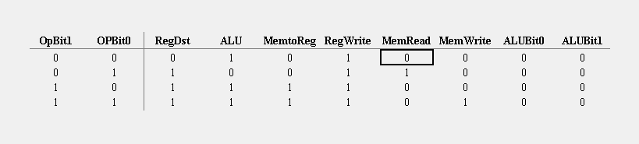

resulting in the following control circuit:

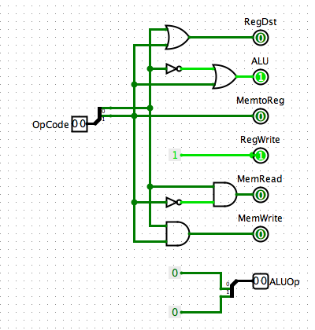

Our mini-MIPS processor would be made according to the following specifications:

• 4-bit processor

• 4 x 4-bit registers

• 4-bit Data RAM

• 8-bit Program RAM

• 4-bit ALU

The processor would follow the following Instruction Set Architecture:

lw rt, offset(rs) # load word from M[rs+offset] to R[rt]

sw rt, offset(rs) # store word from R[rt] to M[rs+offset]

addi rt, rs, const # add immediate R[rt] = R[rs] + const

add rd, rs, rt # add R[rd]=R[rs]+R[rt]

Whereby instructions would be in the format: {opcode; rs; rt; rd/offset/const} – with opcodes as follows:

addi : opcode = 00

add : opcode = 01

lw : opcode = 10

sw : opcode = 11

We began by building the following circuit for our processor which would implement the control circuit created from our truth table above:

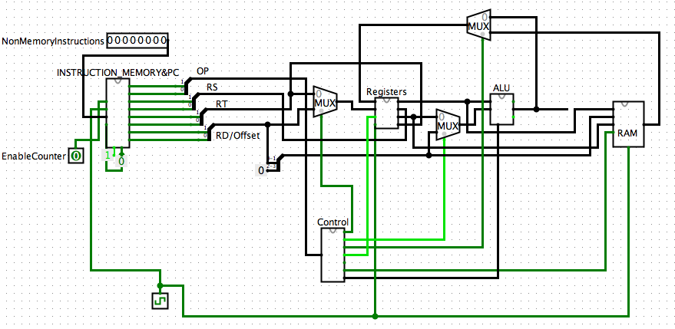

We then tested the circuit by pre-loading the Instruction Memory with the following instructions (in hexadecimal format), the opcode bits of which would in turn be passed to the control unit to pass the necessary control signals to other components within our processor.

|  |  |  |
| --- | --- | --- |
| **Sample Instructions pre-loaded** | | |
| **Instruction (hexadecimal)** | **Instruction (binary)** | **Intended function** |
| 0x12 | 0001 0010 | addi |
| 0x9 | 0000 1001 | addi |
| 0x4b | 0100 1011 | add |
| 0x14 | 0001 0100 | addi |
| 0xdc | 1101 1100 | sw |

When tested our processor successfully read/write values into registers and memory as intended.

**Question 2**

Write an assembly program for the miniMIPS processor that will calculate and store the first 8 Fibonacci numbers in the data memory. Manually assemble the program. Load the machine code into Program RAM. Load a string and key into Data RAM. Execute the program by toggling the clock. Check the final results in Data RAM.

The following MIPS code was used as a guide in testing our processor to produce the Fibonacci numbers which could fit within 4 bits.

|  |
| --- |
| .data  # all registers start at 0  #$t0 - memory address  #$t1-3 used to calculate fibs  datain: .byte 0  #initialise first 2  .text  la $t0, datain  sb $t1, 0($t0) #save fib 0  addi $t0 $t0, 1 #next address  addi $t2, $t2, 1  sb $t2, 0($t0) #save fib 1  addi $t0 $t0, 1 #next address  #####################  #calculate next  add $t3, $t2, $t1  sb $t3, 0($t0) #save fib 2  addi $t0 $t0, 1 #next address  add $t1, $t2, $t3  sb $t1, 0($t0) #save fib 3  addi $t0 $t0, 1 #next address  add $t2, $t1, $t3  sb $t2, 0($t0) #save fib 4  addi $t0 $t0, 1 #next address    ####### copy pasta |

We loaded the following assembly language instructions into the Instruction Memory which would allow our processor to calculate and store the first 8 Fibonacci numbers into data memory.

|  |  |  |  |
| --- | --- | --- | --- |
| **Instruction (binary)** | **Instruction (hexadecimal)** | **Instruction (binary)** | **Instruction (hexadecimal)** |
| 1100 0100 | c4 | 1100 1000 | c8 |
| 00000001 | 01 | 00000001 | 01 |
| 0010 1001 | 29 | 0110 0111 | 67 |
| 1100 1000 | c8 | 1100 1100 | cc |
| 00000001 | 01 | 00000001 | 01 |
| 0110 0111 | 67 | 0110 1101 | 6d |
| 1100 1100 | cc | 1100 0100 | c4 |
| 00000001 | 01 | 00000001 | 01 |
| 0110 1101 | 6d | 0101 1110 | 5e |
| 1100 0100 | c4 | 1100 1000 | c8 |
| 00000001 | 01 | 00000001 | 01 |
| 0101 1110 | 5e | 1100 1000 | c8 |

The below diagram shows the Instruction Memory loaded with the hexadecimal codes for the Fibonacci code as illustrated above:

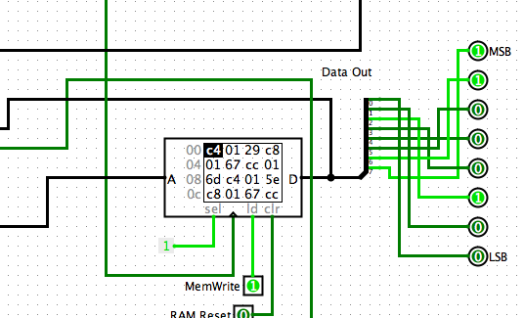

The following diagram shows the contents of the RAM having reached the end of processing the above input. We see the RAM contains the list of all Fibonacci numbers which can be stored within 4 bits.

